COURSE CODE: **ECON04SEC2**

COURSE NAME: **ANALYZING CONTEMPORARY ECONOMIC ISSUES**

SEMESTER: **4**

**GROUP 5:**

NAME: **SAYANI BODHAK**

REGISTRATION NUMBER: **21201220038**

NAME: **PRACHI BISWAS**

REGISTRATION NUMBER: **21201220004**

NAME: **DEBASMITA SAHA**

REGISTRATION NUMBER: **21201220045**

NAME: **ROZMIN ALI**

REGISTRATION NUMBER: **21201260031**

IMPACT OF TERRORISM ON

FOREIGN DIRECT INVESTMENT (FDI),

GROSS DOMESTIC

PRODUCT (GDP),

DEFENCE,

NET TRADE

AND

UNEMPLOYMENT

1. **ABSTRACT**

This paper studies the impact of terrorist attacks on FDI inflows by economic sector in India. It shows the correlation between terrorist attacks and other four variables GDP, unemployment, defence and net trade. In India there is a negative correlation of terrorist attacks with FDI and GDP where as a positive correlation with unemployment, defence and net trade. This paper also shows the comparison between India and Pakistan with respect to those five variables how these variables are related to each other. And finally, it suggests some policy implications taken by the government to reduce terrorist attacks.

***[KEYWORDS****:* ***Terrorist attacks, FDI, GDP, Defence, Unemployment, Net Trade].***

1. **INTRODUCTION**

The very word **“Terrorism”** strikes a feeling of terror in the heart of every existent. Terrorism has been deduced from the French word terrorisme, meaning" great fear". According to the Oxford Dictionary, terrorism means **“ the unlawful use of violence and intimidation, especially against civilians, in the pursuit of political points. ”** When a country is under a terrorist attack, it leads to severe destruction in nearly every sector of the country, unstable frugality and a high feeling of instability among people. People who engage themselves in terrorism always have a particular reason and a perfect thing. Their provocation may be nothing further than hate or the desire for power. An frugality changes at a veritably rapid-fire pace profitable oscillations take place due to numerous reasons.

We've tried to depict how Terrorism has impacted different sectors of a country in this paper. **‘Foreign direct investment (FDI)’** refers to the investment made by a company or an individual from one country into a business or project located in another country. When a country is under a terrorist attack, it’s economically unstable. As a result, investors don't have expedients to get a good return from investing in foreign countries. Their confidence is shaken due to which the foreign direct investment (FDI) starts declining.

**‘Gross Domestic Product (GDP)’** is a measure of the total monetary value of all final goods and services produced within a country's borders during a specific period, typically a year. Income of the people decreases because requests start closing in all sectors. The growth of the frugality starts decelerating down due to numerous other reasons too- after a trauma of a terrorist attack.

In the context of counterterrorism and national security, **defence** refers to the measures, strategies, and actions taken by governments and security forces to protect their citizens, infrastructure, and institutions from terrorist attacks. When terrorist attacks rise, **‘defence’** (security at the borders) rises for better protection of the frugality from terrorism. Generally, we see that, as terrorist attacks increases military cost increases too.

**‘Unemployment’** due to terrorism refers to a specific type of unemployment that arises as a result of terrorist activities and their impact on the economy. It occurs when individuals lose their jobs or are unable to find employment opportunities due to the disruptive effects of terrorism on economic activities. It also increases during terrorist attack because people lose jobs, diligence start shutting down and people come unemployed. Due to the feeling of instability (fear), people leave jobs too.

**‘Net Trade’** is the value of nation’s total export of goods and services minus total import of goods and services. The exports of the country automatically fall due to the attack. People start importing goods. As a result, we find a negative net trade. In this paper, we've illustrated how terrorism impacts the frugality, substantially Foreign Direct Investment (FDI), GDP, defence expenditure, severance and net trade.

1. **LITERATURE REVIEW**

Alam and Mingque (2018) examined the link between FDI, terrorism, and tourism in Pakistan using periodic data from 1995 to 2016. In the long run, a 1% rise in terrorist incidence corresponds to a 0.42 percent loss in FDI and a 0.14 percent drop in TA. The forecasts for the short run are optimistic. In the near run, a 1% rise in TI results in a 0.75% and 0.25% decrease in TA. As a result, we may conclude that the impact of terrorism in the short run is less than its impact in the long run. Furthermore, the impact of terrorism on FDI is less than the impact of terrorism on inbound tourist. These empirical evidences support the notion that overseas investors face binary risks. They are dealing with personal problems as well as the dread of losing their investment.

According to Mohanty et.al.,(2020), defence spending has a significant impact on profitable growth in both the long and short run. Furthermore, although capital defence investment has a positive and considerable influence on profitable growth in both the short and long run, profit defence spending has no effect in either the long or short term. It also discovers that capital conformation has a significant impact on profitable growth in India and that trade openness is more important in the long run than in the short run. Murtaza and Amar (2014) examined the relationship between terrorism and FDI flows to Pakistan utilising time series econometrics as well as data on net FDI overflows and terrorist-related losses. According to the report, FDI flows to some artificial sectors (civic and service-related) are more vulnerable to terrorism than other sectors that draw investments to permanently situated establishments.

According to Shabbir et.al.,(2019), terrorism not only affects frugality, but it also provides the worst environment for transnational investors to remove their investment from that specific country, particularly India. When investors remove their investment partially or entirely, this results in further worker severance in the whole request; moreover, joblessness has a significant impact on labours' household lives. Terrorism, on the other hand, has an impact on commerce since capital outflows outnumber capital inflows in the economy as a whole. Sandler and Enders (2003) investigated 18 Western European nations and discovered that with every new terrorist incident per million people, GDP per capita increases by 0.2 and the proportion of GDP allocated to investment increases by 0.33 percentage points.

According to Lee (2017)'s article, while terrorism can be a hindrance to FDI inflows, governments that accept more counterterrorism help are less prone to this negative effect. It also demonstrates that conflict-related help reduces the detrimental impact of terrorism on FDI by sending a similar signal to international investors. Bandyopadhyay et.al., (2015) established that most countries that had above-average internal or international terrorist attacks between 1970 and 2011 received less foreign direct investment or foreign aid than the average among the 122 nations in the paper's sample. Blomberg et al. (2011) investigated the influence of terrorism on individual income in a variety of nations. They investigated whether the commodities reported using total models are resilient to finer granularity of data. Second, they incorporated social capital indicators akin to trust to assess the extent to which terrorism is connected with trust and if the primary effect of terrorism on income is considerably altered when the indispensable channel is considered.

Enders et al. (2006) calculated that terrorist acts reduced the stock of US FDI by 1% over the whole study period. This stock declined by 5.7 percent in Greece and 6.5 percent in Turkey, respectively. There is still no evidence of a similar impact of terrorist acts on US FDI in any non-OECD nation. In their research, Feridun and Shahbaz (2010) establish that the link between military spending and terrorist acts might have both bad and beneficial implications. Siddique etal., (2017) established that terrorism has a detrimental impact on both foreign and domestic investment in Pakistan from 1980 to 2015. According to Nishat Fatima's (2010) work, the fundamental goal of evaluating the terms of trade in general is to determine if the terms of trade effect has been good or negative. The calculations for Pakistan show that the impact remained negative except for 5 of the 17 sample dates. In average, the effect in 1990-91 pricing was Rs.-33.3 billion per year. As a percentage of GDP, the effect was -1.6 percent every year. This reflected a decrease in gross domestic savings. In 1970 prices, the terms of trade effect was - 533 million in 1971-72 and -1.1 billion in 1980-81 (World Bank(1982)). As a percentage of GDP, this effect is 1.1 percent and 1.4 percent, respectively.

Adesoji Adelaja and Justin George's contribution is important for the following reasons. First, they elaborate on the reason for expecting young severance leading to an increase in domestic terrorist indoctrination by emphasising its role in increasing complaints and easing the reclamation of youthful operators. Second, they distinguish between domestic and foreign terrorism in their empirical study. Third, their empirical approach explains how young adolescence interacts with a variety of institutional issues that the research says are relevant, such as corruption, government effectiveness, and the rule of law. Finally, they employ a range of dependent variable measures, such as the number of terrorist acts and casualties, allowing us to examine both the frequency and harm caused by terrorism, as well as its association with young severance. Terrorism harms trade and interdependence between nations, according to CongS. Pham Hristos Doucouliagos' research. This displacement is greater in Sub-Saharan Africa. The trade spillovers discussed in this research are a result of terrorist acts (e.g., extended time to import, cerebral effect, and income shocks) as well as behaviour to aid such attacks (e.g., heightened security). One key mechanism via which these negative spillover effects work is through advanced trade costs associated with higher trade time as a result of tougher trade and fiscal processes, lower compliance and nonsupervisory load, and trade volatility. The research by Thomas, Adam T(2014) examines the association between domestic labour force participation rates of young adults aged 15- 24 and the product of terrorist effort using country- position data from 2000 to 2009. His findings indicate a negative association between young male and young female labour force involvement and terrorism, but this impact vanishes when both genders are included in a single model. The results are limited by the availability of valid data as well as the possibility of omitted variable bias.

1. **METHODOLOGY**

In this paper, there are two objectives first is to investigate the impact of terrorism on FDI, GDP, Defence expenditure, Unemployment and Net Trade of INDIA and PAKISTAN and second is to look for appropriate policies to reduce or curb the terrorist attacks so that we can maintain a long-lasting economic growth.

In order to proceed to the econometric analysis, it is vital to choose the dependent and independent variables in the paper taking into consideration the data availability. We study Terrorist attacks as the control variable, and GDP, FDI, Defence, Unemployment and Net trade as the dependent variables.

To conduct the pairwise correlation, we first collect the data on terrorism and other variables for both India and Pakistan simultaneously and compare between the countries for better results. The time span for research is 2000-2021 for both the countries.

The data has been collected from World Bank Data or The World Bank: Data (<https://data.worldbank.org/>) and South Asian Terrorism Portal (<https://www.satp.org/>). Then we defined the variables used in our analysis.

**The Case for India**

* FOREIGN DIRECT INVESTMENT (FDI):

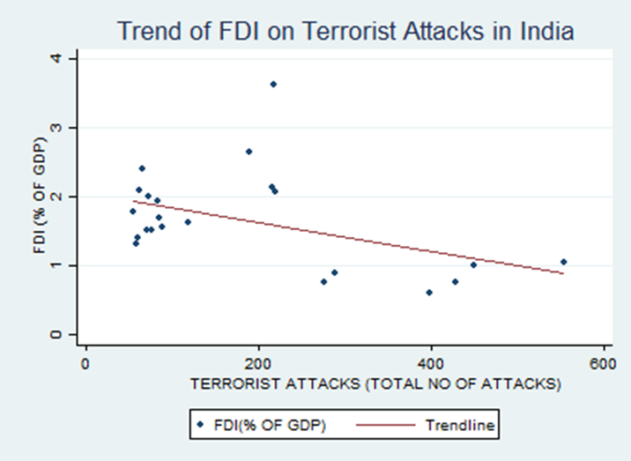

The above graph shows the trend of FDI and Terrorist Attacks in INDIA.

The graph shows that there is an inverse relationship between FDI and terrorist attacks in India, i.e., as terrorist attacks increases, FDI of India decreases and vice- versa. This is because due to increasing terrorist attacks will put a decline in investor’s confidence, making them hesitate to invest in a country that is perceived as unsafe.

* GROSS DOMESTIC INVESTMENT (GDP):

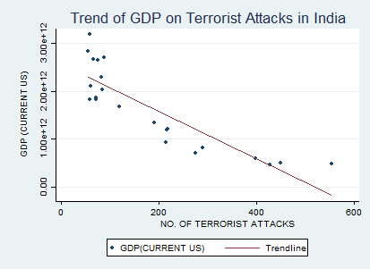

The graph shows the trend of GDP on Terrorist Attacks in INDIA.

In the graph, there is a negative relationship between the GDP and Terrorist Attacks in India, i.e., as terrorist attacks increases, it will decrease the GDP and vice- versa. This is because increasing terrorist attacks will indirectly affect the economy by creating suspicion in the market and affecting the trade sector in particular.

* DEFENCE:

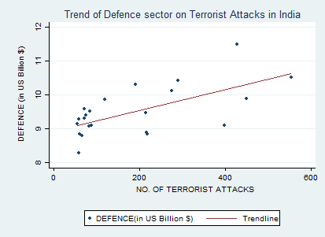

The graph shows the trend of Defence sector on Terrorist Attacks in INDIA.

In the above diagram there is a positive relationship between Terrorist Attacks and investment in defence sector, i.e., as terrorist attacks increases, investment in defence sector by government also increases. This is because terrorism makes the economy unsafe an thus, defence (security at the borders) increases for better protection of the economy.

* UNEMPLOYMENT:

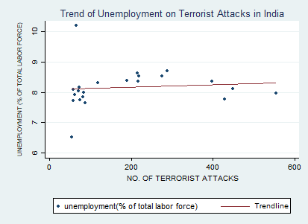

The graph shows the trend of Unemployment on Terrorist Attacks in INDIA.

Here, a positive relation is noticed between unemployment (% of total labor force) and number of terrorist attacks, which is shown by a linear upward sloping trendline between the two variables. This happens because as number of terrorist attacks rises, unemployment also rises (employment falls). As overall growth of the economy falls, people remain unemployed and suffer from loss of jobs.

* NET TRADE:

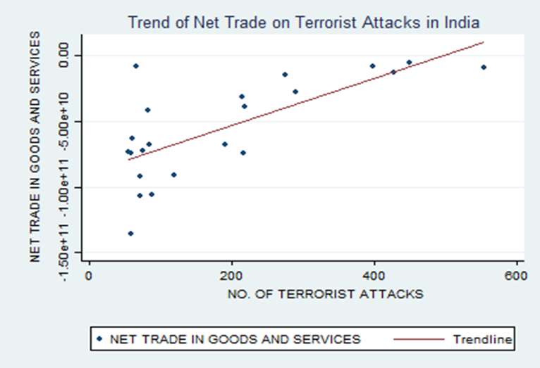

The graph shows the trend of Net Trade on Terrorist Attacks in INDIA.

In the above diagram there is a positive relationship between Net Trade and Terrorist Attacks in India that is as terrorist attacks increases, net rate increases too. But we know that, as terrorist attacks rises, net trade falls. But for the period 2000-2021, it is showing a positive trend for India. The Exports during this particular time period of time was more than the imports of the country and as a result we have a positive Net Trade.

**The Case For Pakistan**

* FOREIGN DIRECT INVESTMENT (FDI):

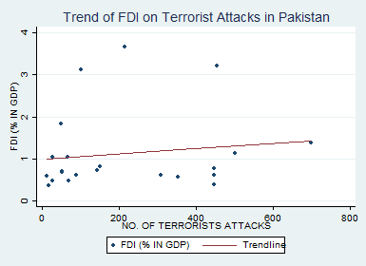

The graph shows the trend of FDI on Terrorist Attacks in PAKISTAN.

Here, we find a slight positive relation between FDI and number of terrorist attacks in Pakistan. The curve is slight upward sloping indicating that as number of terrorist attacks rises, FDI falls by a negligible amount for the period 2000-2021.

* GROSS DOMESTIC INVESTMENT (GDP):

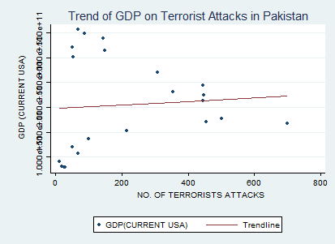

The graph shows the trend of GDP on Terrorist Attacks in PAKISTAN.

In the graph, as terrorist attacks rises, GDP of Pakistan falls by a small amount from 2000-2021, which is shown by a slight upward sloping trend-line between the two variables. The GDP was high during that period.

* DEFENCE:

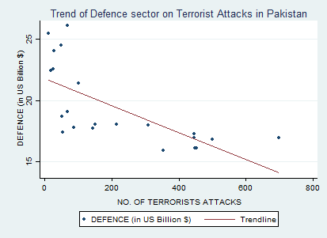

The graph shows the trend of Defence on Terrorist Attacks in PAKISTAN.

In the above diagram there is a highly negative relationship between Terrorist Attacks and investment in Defence sector, that is as terrorist attacks increases investment in defence sector increases. This is because due to increase in terrorist attack GDP of Pakistan increases but they invest more on terrorism rather than investing in defence sector.

* UNEMPLOYMENT :

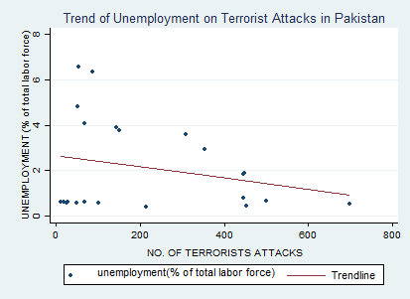

The graph shows the trend of Unemployment on Terrorist Attacks in PAKISTAN.

In the above diagram, there is an inverse relationship between Unemployment and Terrorist Attacks that is as terrorist attacks increases, unemployment increases. This is because the economy of Pakistan recovered at a faster rate during 2000-2021, thus, unemployment did not prevail for a longer period of time. Therefore, employment rose during that period.

* NET TRADE:

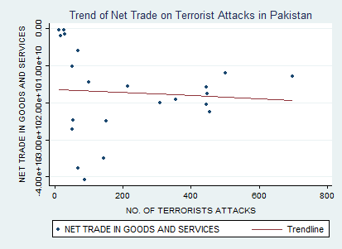

The graph shows the trend of Net Trade on Terrorist Attacks in PAKISTAN.

In the above diagram there is an inverse relationship between Net Trade and Terrorist Attack in Pakistan. As terrorist attacks increase, net trade decreases. This is because Pakistan lost its market shares and therefore remains unable to achieve its targeted growth rates.

1. **COMPARISON OF ALL VARIABLES BETWEEN INDIA AND PAKISTAN**

The above diagram shows the number of terrorist attack in the time period of 2000-2021 in India and Pakistan. In India from 2000-01, number of terrorist attack is increasing. But, in the period of 2001-12, the terrorist attack is increasing at a decreasing rate and from 2012-21, attacks are fluctuating but the rate of attack is very negligible.

Whereas, in Pakistan from period 2000-06, terrorist attack were comparatively low. But from period 2006-09, there is a sharp increase in the number of terrorist attacks. And from period 2010-21, terrorist attacks were decreasing at a decreasing rate.

* FOREIGN DIRET INVESTMENT (FDI):

The above diagram shows the change in the FDI of India and Pakistan from period 2000-21.

In India between period 2000-2008 there is an increase in FDI but it falls rapidly between period 2008-10 and between period 2010-21 FDI is fluctuating. Similarly in Pakistan, the fluctuation is almost same but the FDI (%in GDP) is comparatively low as compared to India.

Here, we can see that the trend of FDI on terrorism in India is below Pakistan from 2000-2008 and then it is above Pakistan from 2009 onwards. This is because the impact of terrorism on FDI in India is much more than Pakistan. This is also one of the reason that the economy of Pakistan recovered at a much faster rate than India during 2000-2021.

* GROSS DOMESTIC INVESTMENT (GDP):

The above diagram shows the change in GDP in India and Pakistan between 2000-2021.

Here, GDP of India is more progressive than Pakistan showing an upward trend with respect to time axis, whereas, for Pakistan it is almost parallel to time axis. This is because terrorism hampers the growth of an economy (both for India and Pakistan), but for Pakistan it is showing a different trend for the given period 2000-2021.

* DEFENCE:

The above diagram shows the change in Defence in India and Pakistan from 2000-2021.

In India, the increase in the Defence between the period 2000-2021 is low as compared to that of Pakistan. The trend of defence on terrorist attacks in India is almost a straight line parallel to time axis, indicating very less fluctuations due to terrorism, whereas, in Pakistan, we can see a highly fluctuating trend between defence and terrorism which is mainly due to the overall growth sector of the economy

* UNEMPLOYMENT:

The above diagram shows the change unemployment in India and Pakistan for the period 2000- 21.

In India, we notice a greater rise in unemployment compared to Pakistan. This is because the economy recovers faster in Pakistan than in India. Thus, unemployment prevails more in India than in Pakistan.

Here, Pakistan has greater fluctuations than India in the unemployment sector. This is because Pakistan's economy grew at a faster rate between 2000-2021, thus adjusting finely with the terrorism index. Thus, unemployment didn't prevail much during that period, hence people got employed in large numbers (employment increased). For India, the economy grew at a slower pace, thus unemployment prevailed for a longer duration within that period. People remained jobless suffering from structural and frictional unemployment.

* NET TRADE:

The above diagram shows change in net trade in India and Pakistan for the period 2000- 21.

Here, India’s net trade is very fluctuating throughout but is less than the net trade in Pakistan. This is because net trade (difference in exports and imports) of Pakistan is greater which indicates that as terrorist attacks rises, net trade falls more. On the other hand, net trade in India falls less as terrorist attacks rises from 2000- 21.

Here, India is having much greater fluctuations than Pakistan. As we know, terrorism deters net trade of an economy by decreasing exports and increasing imports, thus causing a negative trade in the entire economy. For both India and Pakistan, we are getting negative net trade results with respect to terrorism but they differ by their amount and nature. Since, Pakistan's economy adjusted quickly to any changes during that time, so we are not getting that much effect of a negative net trade on terrorism. On the other hand, India still being lagged by its growth system, is having a huge negative impact of net trade on terrorism.

1. **RESULTS:**

* A negative correlation for terrorism indicates that an increase in number of Terrorist Attacks is associated with a decrease in FDI and GDP for India. However, we get positive correlation for Pakistan with respect to FDI and GDP variables. This shows that as the number of terrorist attacks rises, the FDI and GDP falls just like any other country like India. Here, the positive values correspond only for that period 2000-2021 in Pakistan.
* We also see a positive correlation between Terrorism and Defence, Unemployment and Net Trade variables for India. This clearly shows that as number of Terrorist Attacks increases, defence (or security at the borders) also increases, unemployment increases (or, in other words, employment declines) and net trade also increases. Similar observations are noticed for Pakistan as well, but inversely. In other words, as number of terrorist attacks rises, defence, unemployment and net trade falls, which is only restricted (or limited) for that period 2000-2021 in Pakistan.
* The analysis can help policy-makers understand the relationship between the terrorism and other variables and formulate appropriate policies to address the issue.

**DATA:-**

Collected from World Data Bank (<https://data.worldbank.org/>) and South Asia Terrorism Portal (https://www.satp.org/).

|  |  |  |  |  |  |  |
| --- | --- | --- | --- | --- | --- | --- |
|  |  |  |  |  |  |  |

* **DATA FOR PAKISTAN:**

|  |  |  |  |  |  |  |
| --- | --- | --- | --- | --- | --- | --- |
| YEARS | NO. OF TERRORIST ATTACKS | FDI (% OF GDP) | GDP (CURRENT USA) | DEFENCE (US BILLION $) | UNEMPLOYMENT (% OF TOTAL LABOR FORCE) | NET TRADE IN GOODS AND SERVICES |
| 2000 | 18 | 0.375528498 | 82017743416 | 22.422817 | 0.611000001 | -2029000000 |
| 2001 | 28 | 0.475564993 | 79484403985 | 24.032389 | 0.600000024 | -1481000000 |
| 2002 | 26 | 1.033727741 | 79904985385 | 22.569298 | 0.587000012 | -408000000 |
| 2003 | 12 | 0.581949477 | 91760542940 | 25.414372 | 0.600000024 | -435000000 |
| 2004 | 67 | 1.037493764 | 107759683863.12 | 26.057863 | 0.603999972 | -5979990000 |
| 2005 | 50 | 1.833321933 | 120055291992.94 | 24.450557 | 0.591000021 | -10170200000 |
| 2006 | 100 | 3.112977982 | 137264061106.04 | 21.365113 | 0.579999983 | -14558000000 |
| 2007 | 214 | 3.668322816 | 152385716311.92 | 18.027748 | 0.400000006 | -15640000000 |
| 2008 | 454 | 3.197360002 | 170077814106.31 | 16.133473 | 0.419999987 | -22456500000 |
| 2009 | 699 | 1.390402267 | 168152775283.03 | 16.940492 | 0.540000021 | -12838430000 |
| 2010 | 501 | 1.141304858 | 177165635077.07 | 16.834666 | 0.649999976 | -11960000000 |
| 2011 | 446 | 0.6208231 | 213587413184.00 | 16.980737 | 0.800000012 | -15718000000 |
| 2012 | 448 | 0.382826517 | 224383620829.57 | 16.089951 | 1.863999963 | -17528000000 |
| 2013 | 354 | 0.576510795 | 231218567178.98 | 15.906508 | 2.950000048 | -19124000000 |
| 2014 | 446 | 0.772218504 | 244360888750.81 | 17.300467 | 1.830000043 | -20547000000 |
| 2015 | 309 | 0.618355973 | 270556131701.17 | 17.962386 | 3.569999933 | -20018000000 |
| 2016 | 150 | 0.821350368 | 313629858859.59 | 18.032216 | 3.756000042 | -25036898000 |
| 2017 | 144 | 0.735836874 | 339205615769.19 | 17.717625 | 3.913000107 | -35006621000 |
| 2018 | 68 | 0.487745671 | 356128224957.09 | 19.08901 | 4.079999924 | -37647987000 |
| 2019 | 52 | 0.696146445 | 320909489229.72 | 18.69707 | 4.829999924 | -27305928000 |
| 2020 | 53 | 0.68469516 | 300425666773.04 | 17.436242 | 6.550000191 | -24764874000 |
| 2021 | 88 | 0.603567634 | 348262544719.18 | 17.818511 | 6.340000153 | -40826247000 |

* **DATA FOR INDIA:**

|  |  |  |  |  |  |  |
| --- | --- | --- | --- | --- | --- | --- |
| YEARS | NO. OF TERRORIST ATTACKS | FDI  (% OF GDP) | GDP (CURRENT US) | DEFENCE  (US BILLION $) | UNEMPLOYMENT (% OF TOTAL OF LABOR FORCE) | NET TRADE IN GOODS AND SERVICES |
| 2000 | 428 | 0.76521269 | 468394937262.37 | 11.50305704 | 7.769999981 | -13143494265.90 |
| 2001 | 554 | 1.05637835 | 485441014538.64 | 10.52395153 | 7.956999779 | -9180938408.72 |
| 2002 | 449 | 1.01157185 | 514937948870.08 | 9.879555899 | 8.102000237 | -5122207191.99 |
| 2003 | 398 | 0.60588925 | 607699285433.87 | 9.100118151 | 8.359999657 | -8164091361.15 |
| 2004 | 276 | 0.76560145 | 709148514804.66 | 10.11742908 | 8.531000137 | -14960253367.71 |
| 2005 | 289 | 0.88610072 | 820381595512.90 | 10.42312827 | 8.699999809 | -27276336270.91 |
| 2006 | 215 | 2.13016845 | 940259888792.14 | 9.478415923 | 8.625 | -31769964257.37 |
| 2007 | 219 | 2.073395746 | 1216735441524.86 | 8.851182208 | 8.536000252 | -38703712438.72 |
| 2008 | 217 | 3.620521897 | 1198895582137.51 | 8.888781442 | 8.354000092 | -74360043516.29 |
| 2009 | 190 | 2.651593127 | 1341886602798.69 | 10.3147376 | 8.383999825 | -67410018791.40 |
| 2010 | 119 | 1.635034274 | 1675615335600.56 | 9.864230324 | 8.319000244 | -91023662478.72 |
| 2011 | 72 | 2.002065552 | 1823049927772.05 | 9.592767418 | 8.168000221 | -106686782608.97 |
| 2012 | 58 | 1.312934337 | 1827637859506.25 | 9.272621064 | 8.095000267 | -136063399026.17 |
| 2013 | 71 | 1.516275965 | 1856722121394.42 | 9.295983197 | 8.036999702 | -92135051692.14 |
| 2014 | 84 | 1.695658786 | 2039127446299.30 | 9.50479049 | 7.980999947 | -67969807623.77 |
| 2015 | 61 | 2.092115758 | 2103587813812.75 | 8.830488016 | 7.914999962 | -63249171394.85 |
| 2016 | 82 | 1.937363198 | 2294797980509.01 | 9.079497386 | 7.842000008 | -41579206265.01 |
| 2017 | 75 | 1.507316581 | 2651472946375.05 | 9.389757969 | 7.732999802 | -72211612625.34 |
| 2018 | 88 | 1.558214793 | 2702929718960.46 | 9.102595967 | 7.650000095 | -105917684940.61 |
| 2019 | 55 | 1.787381739 | 2831552222519.99 | 9.13684004 | 6.510000229 | -73451671322.59 |
| 2020 | 65 | 2.41266468 | 2667687951796.50 | 8.793986887 | 10.19499969 | -8342168264.00 |
| 2021 | 59 | 1.408158771 | 3176295065497.24 | 8.271418896 | 7.712999821 | -74039374427.90 |

**VII. POLICIES TO REDUCE TERRORIST ATTACKS AND WAYS TO GET A STABLE ECONOMY**

1.Counterterrorism Measures: Governments can adopt comprehensive counterterrorism strategies that include intelligence gathering, surveillance, and preventive actions to identify and disrupt terrorist activities. This involves collaboration among law enforcement agencies, international cooperation, and sharing of intelligence to effectively combat terrorism.

2. Enhance Security Measures: Strengthening security measures is crucial to prevent terrorist attacks and ensure public safety. This may involve enhancing border security, implementing stringent airport and transportation security protocols, securing critical infrastructure, and increasing security presence in public spaces.

3. Address Root Causes: To address the underlying factors that contribute to terrorism, policies should focus on addressing socio-economic grievances, inequality, and political instability. This can include promoting social inclusion, improving access to education and healthcare, reducing poverty, and promoting good governance and political reforms.

4. International Cooperation: Terrorism is a global issue, and cooperation among nations is essential. Sharing intelligence, coordinating efforts to track and freeze terrorist financing, and collaborating in investigations and prosecutions can help disrupt transnational terrorist networks.

5. Community Engagement and Countering Extremist Ideologies: Governments can work with local communities, civil society organizations, and religious leaders to counter extremist ideologies and promote social cohesion. This can involve initiatives such as community outreach programs, promoting interfaith dialogue, and supporting rehabilitation and reintegration programs for individuals vulnerable to radicalization.

Regarding achieving a stable economy, the following measures can be considered:

1. Macroeconomic Stability: Implementing sound monetary and fiscal policies that promote price stability, low inflation rates, and sustainable public finances can contribute to economic stability. This includes maintaining a balanced budget, effective tax policies, and prudent management of monetary policy.

2. Investment in Infrastructure: Investing in infrastructure development can stimulate economic growth, create jobs, and attract private investment. Improving transportation networks, energy systems, and telecommunications infrastructure can enhance productivity and competitiveness.

3. Promote Business Environment: Creating a conducive business environment through policies that encourage entrepreneurship, innovation, and private sector growth is essential for economic stability. This can involve reducing bureaucracy, streamlining regulations, ensuring the rule of law, protecting property rights, and facilitating access to finance for businesses.

4. Human Capital Development: Investing in education and skills training equips the workforce with the necessary knowledge and skills to drive economic growth. This can involve improving access to quality education, vocational training, and lifelong learning opportunities.

5. Trade and Investment Liberalization: Promoting open and fair trade, reducing barriers to international trade and investment, and participating in regional and global trade agreements can enhance economic stability and create opportunities for businesses to expand.

**VIII. CONCLUSION**

The inflow of FDI in the developing countries is crucial because it enables the improvement of the socio-economic, political and regulatory framework and eventually it promotes the economy’s economic growth. The purpose of the present study is the empirical investigation of the interaction between terrorist attacks and FDI in India during the period 2000-2021. In addition to this, we studied Pakistan to compare under the criterion that this country presented the highest rates of terrorism in the world. This study has shown a significant but inconsistent relationship between terrorist attacks and foreign direct investment and gross domestic product but, provided a consistent relationship with defence sector in particular.

Terrorism has a significant impact on FDI in India by creating a sense of insecurity and instability, disrupting the normal functioning of businesses, and affecting the government's response to the issue. Therefore, it is crucial for the government to take effective measures to counter-terrorism and ensure the safety and security of foreign investors in the country. Terrorism disrupts the normal functioning of businesses, leading to a decrease in productivity and profitability, which can also impact FDI. Moreover, the government's response to terrorism can also affect FDI, as an ineffective response can create a negative perception of the country among foreign investors. On the other hand, the impact of terrorism on FDI in Pakistan from 2000-2021 has been significant and negative. The country has faced numerous terrorist attacks during this period, which have led to a decline in foreign investment and a reduction in economic growth. Furthermore, terrorism has also had a broader impact on Pakistan's economy and society, leading to increased poverty, social inequality, and a decline in economic growth. In conclusion, the impact of terrorism on FDI in Pakistan between 2000 and 2021 has been significant and negative. Pakistan will need to continue implementing policies that reduce the threat of terrorism and promote economic growth if it wants to attract foreign investment in the future.

Terrorism also has a significant impact on the Gross Domestic Product (GDP) sector of India. Terrorism can affect the economy by disrupting the normal functioning of businesses, leading to a decline in productivity and profits. Additionally, terrorism increases the cost of security, which can put a strain on the government's budget, leading to reduced spending on other sectors such as healthcare, education, and infrastructure. Therefore, it is crucial for the government to take effective measures to counter-terrorism and promote a safe and secure business environment. Terrorism has disrupted economic activity in Pakistan by damaging infrastructure, creating an environment of insecurity and instability, and reducing investor confidence. This has led to a decline in economic growth and a reduction in GDP, particularly in sectors such as tourism, manufacturing, and services. Furthermore, terrorism has also had a broader impact on Pakistan's economy and society, leading to increased poverty, social inequality, and a decline in foreign investment. However, it is important to note that Pakistan has also taken steps to counteract the negative effects of terrorism on GDP. The government has implemented various security measures to prevent terrorist attacks, and there have been efforts to promote economic growth through policies aimed at attracting foreign investment and increasing domestic production. In conclusion, the impact of terrorism on GDP in Pakistan from 2000-2021 has been significant.

Terrorism has a significant impact on the defence sector of India. Terrorism is a major security threat that requires significant investment in defence and security infrastructure. It also affects the morale and readiness of the armed forces, leading to a decline in their effectiveness. The government may also need to allocate additional resources to counter terrorism, which can impact the overall defence budget; it must take effective measures to counter terrorism and ensure that the defence sector is adequately prepared to tackle security threats. Terrorism has posed a major challenge to Pakistan's defence capabilities, as militants have targeted military personnel, installations, and equipment. This has led to a loss of life and resources, and has required a significant amount of time and resources to address. Furthermore, the threat of terrorism has also led to increased military spending in Pakistan, as the government has had to allocate additional resources to enhance its defence capabilities and counter the terrorist threat. The government has implemented various security measures to prevent terrorist attacks and has strengthened its cooperation with international partners in the fight against terrorism. In conclusion, the impact of terrorism on defence in Pakistan from 2000-2021 has been significant, but the country has also demonstrated resilience and the ability to adapt to the evolving threat.

Terrorism has disrupted economic activity in India, but the impact on employment has been minimal. In fact, in some cases, the government's response to terrorism has actually created employment opportunities, such as the recruitment of security personnel and the creation of new security agencies. Furthermore, India's large and diverse economy has also helped to mitigate the impact of terrorism on employment. However, it is important to note that terrorism can have indirect effects on employment, such as a reduction in investment and economic growth, which can lead to job losses in the long run. Terrorism has disrupted economic activity in Pakistan by damaging infrastructure, creating an environment of insecurity and instability, and reducing investor confidence. This has led to a decline in economic growth and job creation, which has had a direct impact on unemployment in the country. Furthermore, terrorism has also had a broader impact on Pakistan's society, leading to increased poverty, social inequality, and displacement. Many people have been forced to leave their homes and communities due to the threat of terrorism, which has further exacerbated unemployment and poverty. The government has implemented various measures to address these challenges, including security operations against militant groups, economic development initiatives, and job creation programs.

Terrorism has disrupted economic activity in India which has an indirect impact on net trade. The country's exports and imports are affected by a reduction in foreign investment and a decline in economic growth. Furthermore, terrorism can also affect trade by disrupting supply chains and causing delays in the transportation of goods. In addition, terrorist attacks can also lead to a decline in tourism, which can have a significant impact on net trade. However, despite the threat of terrorism, India has managed to maintain its position as one of the world's largest exporters and importers of goods and services. India has also taken steps to counteract the negative effects of terrorism on net trade. The government has implemented various security measures to prevent terrorist attacks and has strengthened its cooperation with international partners in the fight against terrorism. Terrorism has disrupted trade and investment in Pakistan and has a negative impact on the country's exports and imports, as well as on foreign investment. Furthermore, terrorism has also had a broader impact on Pakistan's economy and society, leading to increased poverty, unemployment, and social inequality. The government has implemented various security measures to prevent terrorist attacks, and there have been efforts to promote economic growth through policies aimed at attracting foreign investment and increasing domestic production.

**IX. REFERENCES**

* Enders et al.,(2006). *The Impact of Transnational Terrorism on U.S. Foreign Direct Investment.*
* Blomberg et al.,(2011). *Terrorism and the economics of trust. Journal of Peace* *Research*, 48(3), 383–398. [<https://doi.org/10.1177/0022343311401641>].
* Sandler & Enders,(2003). *ECONOMIC CONSEQUENCES OF TERRORISM IN DEVELOPED AND DEVELOPING COUNTRIES: AN OVERVIEW.*
* Murtaza & Amar,(2014). *Impact of terrorism on FDI flows to Pakistan. Toronto*.
* Siddique et al.,(2017). *Impact of Terrorism on Investment: Evidence from Pakistan.* Vol. 6, Bulletin of Business and Economics.
* Shabbir et al.,(2019). *Impact of Terrorism on Exclusive Indian Economy*. Vol. 5, Journal of Indian Studies 29 Journal of Indian Studies.
* Mohanty et al.,(2020). *Does Defence Spending and its Composition Affect Economic Growth in India? Margin.* Feb 1;14(1):62–85.
* Alam & Mingque,(2018).*The Relationship between Terrorist Events, Foreign Direct Investments (FDI) and Tourism Demand: Evidence from Pakistan. American Journal of Tourism Management* [Internet]. 7(1):10–8. [Available from: <http://journal.sapub.org/tourism>].
* Bandyopadhyay et al.,(2015). *The Toll of Terrorism.*
* Feridun & Shahbaz,(2010). *Fighting terrorism: Are military measures effective? Empirical evidence from Turkey. Defence and Peace Economics*. Apr;21(2):193–205.
* Blomberg et al.,(2004). *Economic conditions and terrorism. Eur J Polit Econ* [Internet]. 20(2):463–78. [Available from: <https://www.sciencedirect.com/science/article/pii/S0176268004000217>].
* Lee,(2017) *Terrorism, Counterterrorism Aid, and Foreign Direct Investment. Foreign Policy Analysis* [Internet]. 13(1):168–87. [Available from: <https://www.jstor.org/stable/26168140>].
* *NO. OF TERRORIST ATTACKS IN INDIA*, n.d. [<https://www.satp.org/datasheet-terrorist-attack/major-incidents/india> ].
* *NO. OF TERRORIST ATTACKS IN PAKISTAN*, n.d. [<https://www.satp.org/datasheet-terrorist-attack/major-incidents/pakistan>].

**X.APPENDIX**

* GANTT CHART:

|  |  |  |  |  |  |  |  |  |
| --- | --- | --- | --- | --- | --- | --- | --- | --- |
| WORKLOAD | MARCH |  | APRIL |  |  |  | MAY |  |
|  | 3RD WEEK | 4TH WEEK | 1ST WEEK | 2ND WEEK | 3RD WEEK | 4TH WEEK | 1ST WEEK | 2ND WEEK |
| **GROUND WORK** | x | x |  |  |  |  |  |  |
| **LITERATURE REVIEW** |  | x | x | x |  |  |  |  |
| **METHODS & METHODOLOGY** |  |  |  | x | x |  |  |  |
| **DATA COLLECTION** |  |  | x |  |  |  |  |  |
| **PROGRESS SEMINAR** |  |  | x |  |  |  |  |  |
| **DATA ANALYSIS** |  |  | x | x |  |  |  |  |
| **WRITE FIRST DRAFT** |  |  | x |  |  |  |  |  |
| **WRITE SECOND DRAFT** |  |  |  | x |  |  |  |  |
| **WRITE THIRD DRAFT** |  |  |  |  | x |  |  |  |
| **WRITH FOURTH DRAFT** |  |  |  |  |  | x |  |  |
| **FINAL DRAFT** |  |  |  |  |  |  | x |  |
| **FINAL SEMINAR** |  |  |  |  |  |  |  | 10th |

* **CODING BOOK:**

|  |  |  |  |  |  |  |
| --- | --- | --- | --- | --- | --- | --- |
| TITLE | AUTHOR | OBJECTIVES | METHODS | DATA SOURCE | VARIABLES | MAJOR FINDINGS |
| Does Defence Spending and its Composition Affect Economic Growth in India? | Ranjan Kumar Mohanty, Sidheswar Panda,Biswabhusan Bhuyan | The article investigates the relationship between economic growth and defence expenditure in India from 1970–1971 to 2015–2016. | Autoregressive Distributed Lag and Toda-Yamamoto Granger Causality approach | Handbook of Statistics on the Indian  Economy, the Reserve Bank of India (RBI), the database on the Indian economy  and the National Accounts Statistics of the Central Statistics Office |  | The findings of the study suggest for restructuring the composition of  India’s defence spending in favour of greater capital defence spending (without  a reduction in revenue defence spending, which is necessary for the smooth  functioning of the sector) |
| The Impact of Transnational Terrorism on U.S. Foreign Direct Investment | WALTER ENDERS, ADOLFO SACHSIDA,TODD SANDLER, | This article investigates the extent to which transnational terrorist attacks altered U.S. foreign direct investment (FDI) | time-series intervention analysis, panel estimation | International Terrorism: Attributes of Terrorist Events (ITERATE) | FDI flows, terrorist attacks | Although 9/11 was a watershed event with huge immediate economic consequences , 9/11 only slightly interrupted  the substantial growth in U.S. FDI flows in the current era of globalization |
| Terrorism, Counterterrorism Aid, and Foreign Direct Investment | Chia-yi Lee | This paper explores whether terrorism reduces foreign direct investment (FDI) inflows and argues that foreign investors adjust their information by observing whether the country has the ability to deal with terrorism. | time-series cross-sectional data analysis | Google search | terrorism, counterterrorism, FDI inflows, | this paper finds that while terrorism can be an obstacle to FDI inflows, countries that receive more counterterrorism aid are less vulnerable to this adverse effect. |
| Terrorism and the economics of trust. Journal of Peace Research, | Blomberg, B., Hess, G. & Tan, D. | This article investigates the effect of terrorism on income, including its indirect role through lowering trust. | meta analysis | International Terrorism: Attributes of Terrorist Events dataset, Penn World Table | Income Trust Terrorism Age Education Children Unemployment |  |
| The relationship between FDI, Terrorism in Pakistan | Mir Alam, Ye Mingque | To analyse the relationship between terrorism & FDI for United States | autoregressive integrated moving average (ARIMA) analysis with a transfer function | ITERATE data set | Terrorist Incidence (TI), Proxies Foreign Direct Investment (FDI), Total terrorist attack (T.A) | The short run impact is greater than the long run impact of terrorism on FDI; the FDI sector faces the life threat threats as well as the fear of loss in investment. |
| Impact of terrorism on FDI flows to Pakistan | Haider, Murtaza and Anwar, Amar | This study explores the adverse impacts of terrorism on the net Foreign Direct Investment  (FDI) flows to Pakistan | Auto-regressive Integrated  Moving Average (ARMAX) Model | They obtained the time series data on net FDI from the State Bank of Pakistan (SBP). | Foreign Direct Investment; Terrorism; | FDI flows to certain industrial sectors  (urban and service-oriented) are more susceptible to terrorism than other sectors that  attract investments to remotely located facilities. |
| Impact of Terrorism on Exclusive Indian Economy | Malik Shahzad Shabbir, Maleeha Kiyani, Aniqa Zeb | to investigate at what extent Indian economy becomes the victim of terrorism activities | auto regress or distributed lags (ARDL) method | South Asia Terrorism Portal (SATP) | gross domestic product (GDP) as dependent variables and foreign direct  investment (FDI), terrorism (TR),net trade (NT), interest rate (IR), and unemployment (UM) | in short run analysis only terrorism has found a negative relationship with economic growth, while rest of all variables are statistical significant |
| The Toll of Terrorism, FINANCE & DEVELOPMENT | Subhayu Bandyopadhyay, Todd Sandler, and Javed Younas | They explored the economic burden of terrorism |  | Author's Calculations | national income losses and growth-retarding effects, dampened foreign direct investment, and disparate effects on international trade. | although terrorism may reduce trade in a particular product because it increases transaction costs, its ultimate impact may be either to raise or reduce overall trade. |
| Impact of Terrorism on Tourism in India | Yashobanta Parida, Parul Bhardwaj | examining the impact of terrorism activities on inbound tourism and foreign exchange earnings from tourism in India | Autoregressive Distributed Lag Model | Hand Book of Statistics on Indian Economy, India's Tourism Statistics | per capita income, Foreign Tourist arrival, foreign Exchange earnings, fixed telephone subscriptions, railway line | The long-run estimates show that economic development has a positive impact on both foreign tourist arrival and foreign exchange earnings from tourism in India. On the other hand, terrorist activities have an adverse impact on both foreign tourist arrival and foreign exchange earnings from tourism in India. |
| The Impact of Terrorism and Conflicts on Growth in Asia,  1970–2004 | Khusrav Gaibulloev and  Todd Sandler | This paper quantifies the impact of terrorism and conflicts on income per capita growth in Asia for 1970–2004. | Two way fixed effects estimation of growth model, summary statistics | Penn World Table Version 6.2 (Heston, Summers, and Aten 2006), International Terrorism: Attributes of Terrorist Events (ITERATE)  (Mickolus et al. 2006), Global Terrorism Database (GTD), and the UCDP/PRIO Armed  Conflict Dataset | Income, growth, economic open ness, investment, population, government expenditure, transnational terrorist events, external conflict, internal conflict | Both internal and  external conflicts crowd in government spending of a similar magnitude that is about twice as  large as that from transnational terrorism. General terrorism, as measured by GTD, does not influence  economic growth directly but indirectly by reducing investment shares. |
| Is Youth Unemployment Related to Domestic Terrorism? | Adesoji Adelaja and Justin George | they investigated the possible contributions of  youth unemployment to domestic terrorism using a cross-country panel database. | binomial regression | Global Terrorism Database (GTD) | GDP per capita, population , unemployment, domestic terrorist attacks | we make a distinction between domestic and transnational terrorism; we expand on the rationale for expecting youth . |
| The Impact of terrorsim on FDI :Evidence from FDI | Rabia Liaqat and Kaleem Ullah | To find out the impact of Terrorism on Domestic Investment and Foreign Investment | Econometric models | World Development Indicator | Foreign direct investment and domestic investment | there is a negative impact of Terrorismon FDI and domestic investment |